When it Comes to the Brain, Exercise May be the
Fountain of Youth
Why physical activity is key to preventing Alzheimer’s disease and prolonging independence
-------------
BY KATIE BROWN

ging is a process most of us dread. In fact, we dread getting old so much, we spend nearly $290 billion a year trying to slow, reverse, or otherwise halt the aging process, according to the American Academy of Anti-Aging Medicine. Yes, there is an entire academy devoted to this booming industry. Aging brings about the familiar myriad of unwelcome cosmetic changes: wrinkles, gray hair, varicose veins, and stooped posture. Inside our bodies, the aging process takes its toll in the form of decreased bone density, brain volume, and cell divisions. These microscopic decreases manifest into changes we are all too familiar with: taking longer to heal, sagging skin, and forgetfulness. Arguably, the most feared sign of aging is the onset of Alzheimer’s disease, the slow disintegration of the mind---this process happens so slowly that it usually goes unnoticed and undiagnosed. Currently, there exists no known cure for Alzheimer’s, or dementia of any kind. Because of this, the prognosis for Alzheimer’s patients has always been grim. However, new research is offering some hope for the 5.1 million Americans currently affected. According to widely corroborated findings, incorporating aerobic exercise into your routine may not only delay the onset of Alzheimer’s disease, but actually slow disease progression.

The Impact of the Aging Baby Boom Generation
An Alzheimer’s diagnosis is a heavy emotional burden for both the patient and the family caregivers. The gradual decline and loss of function leads to increasing reliance on the younger generations to support the elderly in their sunset years. With more people living longer, maintaining quality of life for the 88.5 million Americans over age 65 is a major concern. By 2050, an estimated 20% of the US population will be over 65 years old. The largest segment of the population will be what scientists divide into the “young-old” (65-79 years) and the “oldest old,” or those aged 80 years and older. As it turns out, that segment of the population is not being replaced by younger Americans, either. The age distribution pyramid for the US is getting increasingly top heavy and looking to stay that way for a while. After age 65, chances of developing Alzheimer’s disease double every five years. This already envelops a significant portion of the population and when you factor in the 500,000 Americans with early onset dementia, a number on the rise, these numbers alone foreshadow a major public health issue. The real numbers that seal the deal however, are the millions of family members acting as unpaid, unsung caregivers.
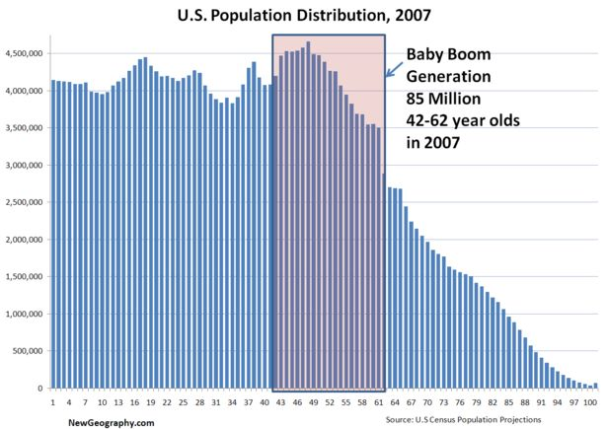
The psychological toll for patient and family is dually compounded by the financial toll taken in the form of missed work, insurance costs, and lost productivity. The Alzheimer’s Foundation of America reports that these factors affecting the primary caregivers cost businesses approximately $60 billion per year and that usually one to four family members act as caregivers for each patient. This leads to astronomical losses in productivity, but an even greater amount of money is poured into treatments.
Annually, upwards of $100 billion is spent on benign treatments. Interestingly, the smallest budget is in the research sector. The federal government spends $640 million per year on funding research, a figure that is dwarfed by the societal cost of Alzheimer’s, let alone the billions spent on “treatments.” Though the disparities are striking, the current best message emphasizes getting your heart pumping with regular aerobic exercise may be the most effective treatment approach to keep your mind sharp. Here’s why it works.

The Biology of Alzheimer’s Disease
Alzheimer’s disease has been called the “mind stealer.” Acting like a thief under the cover of darkness, the early physiological changes are nearly as discreet. It is only at the most severely progressed stages of the disease that changes become noticeable. Alzheimer’s primarily attacks the frontal
and temporal lobes of the brain. These two lobes are primarily responsible for executive functioning tasks, such as decision-making, ability to adapt in novel situations, multi-tasking, working memory, and planning---basically the stuff that
Age histogram demonstrating the growing portion of the United States population aged 41-61, the Baby Boomers. This segment of
the population is expected to relatively maintain its population density into their 7th.8th, and 9th decades.

makes us human and sets us apart from animals. Onset coincides with a loss of brain volume in these lobes. The volume loss occurs as a result of neurons dying. The exact reason, as well as method, for neuronal death is the topic of intense scientific research.
The most recent theory involves plaques and tangles, black structures found ubiquitously in the brains of autopsied Alzheimer’s patients. Scientists have begun to implicate plaques and tangles as the cause, instead of as the graveyard remnants of a disease ravaged brain. Plaques are the hardened shell of neurons that have been attacked by beta-amyloid, a chemical released as part of an inappropriate immune response by the brain. For unclear reasons, your brain starts to attack its own neurons. The high levels of beta-amyloid are toxic to neurons and cause them to harden and die, leaving behind plaques.
Tangles are the literal snarled remnants of the protein, tau, the “tracks” of railroad shaped glial cells, or support neurons that do not conduct electrical signals. Glial cells provide nutrition to the impulse conducting neurons that allow us to think, move, and speak. For reasons still unknown, tau becomes rigid, breaking off, and tangling the whole glial cell so that it can no longer sufficiently provide nutrients to the neuron. The neuron starves and dies.

The Benefits of Exercise
Although exercise is beneficial for the whole body, the specific neurological effects are not global; they are specific to the executive functioning brain structures. A 2006 study found that aerobic training actually increased brain volume for previously sedentary individuals. This means that engaging in any kind of aerobic exercise (walking, jogging, or any activity that results in an increased heart rate), can increase the volume of the brain lobes stricken by Alzheimer’s, even if you have never exercised before.
This happens because the body releases a growth factor that makes new blood vessels in your brain. This means more blood can flow to your brain, which is actually used as a measure of cognitive processing. Increased cerebral blood flow, in turn, induces the birth of new neuronal connections, or dendrites, which brings the cycle full circle to increase brain volume. Furthermore, physical activity stimulates the release of brain derived neurotrophic factor (BDNF) which maintains neural integrity and health. This entire process can take place in as little as three months post-workout. This is an incredible pace. Think about how long it takes to see the kind of results from the gym that you want: muscle definition, weight loss, and increased energy. This kind of change literally changes your brain structure and happens in just three months with life-long benefits.

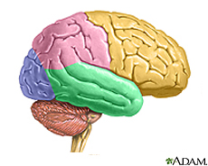
What Alzheimer’s Looks Like. The decline of the mind in pictures.

Frontal lobe

Temporal
Lobe Primary structures responsible for executive functioning: planning, decision-making, multi-tasking.
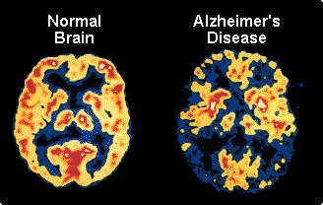
Decreased levels
of activity, as well as
loss of volume for an
Alzheimer’s affected
brain, on the right.

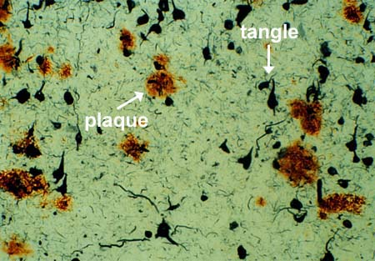

The culprits:
plaques and
tangles.

EXERCISE INTERVENTION
It is all about increasing the density of neurons in the frontal lobe to preserve cognition.

The Take-Home Message
According to the research, keeping your wits about you may be as simple as incorporating exercise into your routine. To reap the benefits however, the activity chosen must be aerobic in nature, in that it taxes the cardiovascular system by increasing heart rate and breathing. Even simple changes that make your lifestyle more active, such as standing more, taking the stairs, vacuuming, etc. can count as activities that lead to increased brain volume. These kinds of low intensity, daily activities are called Activities of Daily Living and are particularly useful to take into account for older populations. Of course, more structured, regularly scheduled bouts of exercise are the most beneficial.
The bottom line is that any physical activity is better than not moving at all. Even without any previous experience exercising, starting a physical activity regimen can stave off or slow progression of Alzheimer’s disease if you are currently experiencing symptoms. Exercise increases brain volume while learning enhances their survival, so the best bet to “age successfully” is an aerobic exercise regimen topped off with new experiences. Maybe, you really can teach an old dog new tricks.

